EYERIS_ A Virtual Eye to Aid the Visually Impaired
Alternative Title:
Personal Assistive System for Deaf-Blind People Using Raspberry pi and Machine Learning
Aim:
Aim of this project is to develop a personal assistant system for deaf-blind people to help identify faces of people and objects in terms of Morse code.
Synopsis:
In the era of artificial intelligence lot of object and face detection devices are available for visually impaired people. When it comes to subject of deaf-blind people there is none of devices available in market. For them, only communication devices like MyVox, Sparsha are available rather than personal assistive devices. In this project we are going to propose a personal assistive device to help deaf-blind people using Machine learning and Morse code.
It consists of multiple in-built options like object detection, facial recognition and communication module. For object detection, we are using Machine learning objection detection model which is trained by CNN algorithm. It can detect multiple objects at same time and detected objects name is intimated to user by tactile vibrations. For face detection, first we are collecting dataset and trained them into CNN model. Using this model we can recognize trained faces and can intimated user when only device in face identification mode. To make communication between users with other people we are using Google speech recognition and text to speech conversion. Every text appeared in the module is converted into Morse code to make corresponding tactile vibrations.

Existing System:
Existing system designed to assist visually impaired people by performing object detection and face recognition. It uses headphone to intimate presence of object and person by means of audio.
Proposed System:
Proposed system utilizes the Morse code to convert every text into vibrations using micro vibrators. Buttons are used to generate Morse code by user and converted into audio. For object detection, tflite model is used instead of conventional machine learning models. tflite model helps to increase the frame rate while using ARM based microprocessors.

Block Diagram:
Raspberry Pi 4

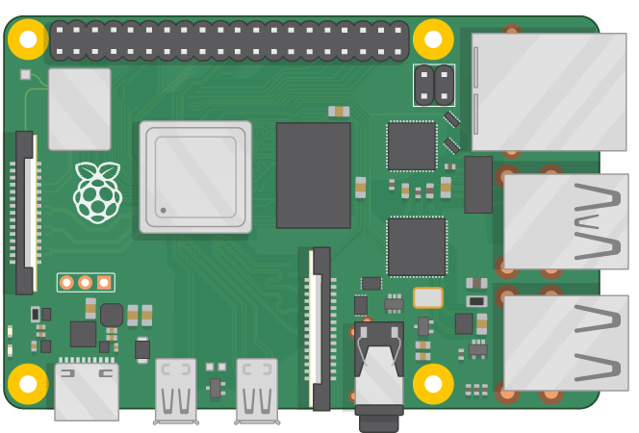
USB camera
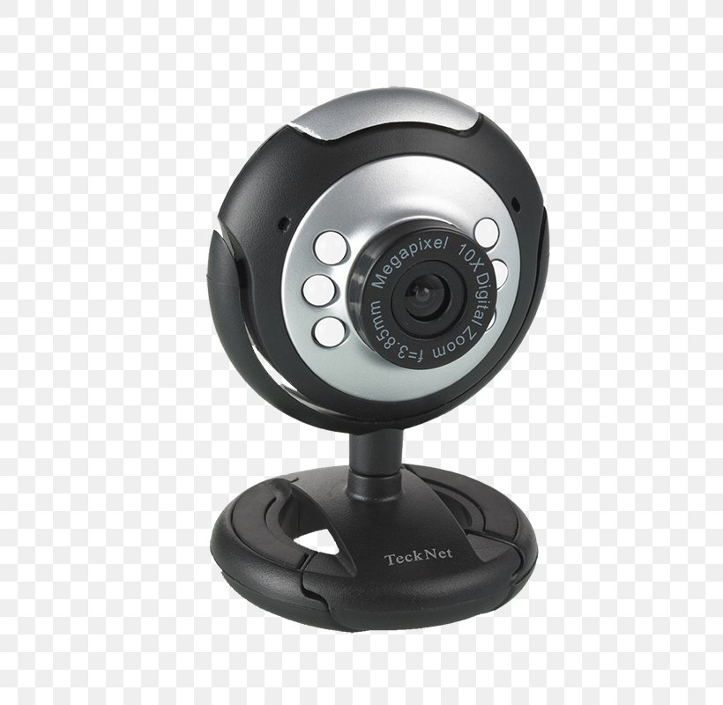
Headphone
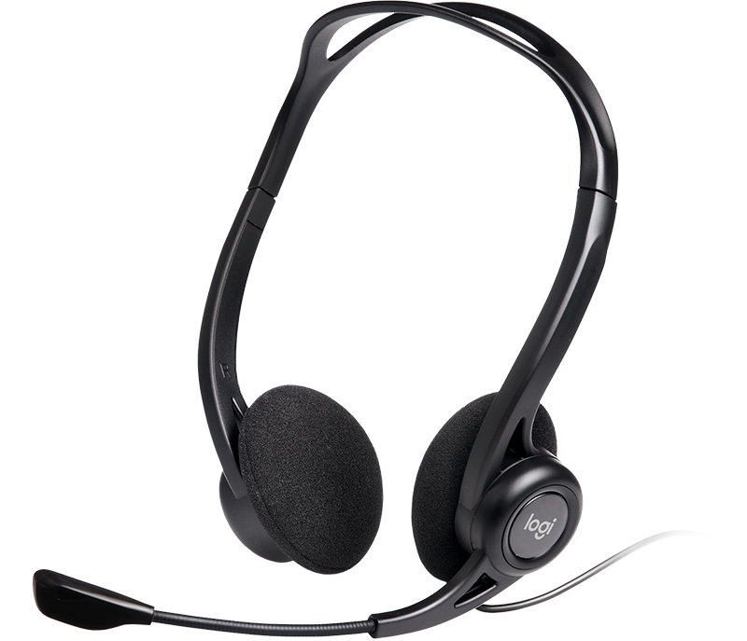
Push Button
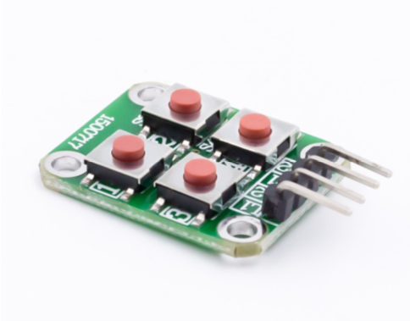
Deaf-Blind User
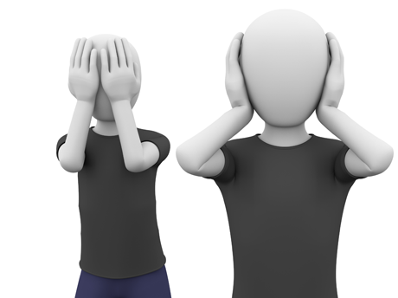
Speaker/Normal user

Tactile Vibrators 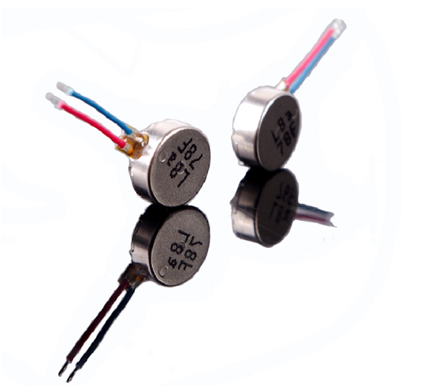

Block Diagram Description:
In this Block Diagram, USB camera, push buttons and one microphone used as input devices and five haptic motors and one speaker used as output devices to the controller. Here, Raspberry Pi is used as controlling unit. Microphone used to get voice input from normal people and button used to get input from impaired people. When the speech to text conversion completed it gives to the encoding section and gives the user understandable vibrating output via haptic motors. Depending on the button status message of user conveyed to normal people via speaker. Same method is used to intimate the presence of objects and person recognition. Detected object or person name is received as text from machine learning model. This text is again converted into Morse code.
Hardware requirements:
- Microphone
- USB camera
- Buttons
- Toggle Switch
- Vibrators
- Raspberry Pi
- Speaker
Software requirements:
- Language : Python
- Compiler : GCC Complier.
- OS : Linux

